Operation Analytics and Investigating Metric Spike



PROJECT DESCRIPTION

Operation Analysis is the analysis done for the complete end-to-end operations of a company. With the help of this, the company then finds the areas on which it must improve upon. I,ve worked withnthe ops team, support team , marketing team and help them derive insights out of the data they collect.

Being one of the most important parts of a company, this kind of analysis is further used to predict the overall growth or decline of a company’s fortune.

Investigating metric spike is also an important part of operation analytics as being a Data Analyst I,ve made the other teams understand questions like- why is there a dio in daily engagement? Why have sales taken a dip etc.

Questions like these must be answered daily and for that its very important to invstigate the spike.



Tech-Stack Used

Used MySQL Community Server (version 8.0.34 connector version C++ 8.0.34 for creating the database)

Microsoft Excel (for import and export data)

MS Word ( for project file)





**Case Study 1:**

**Job Data Analysis**

**Tasks:**

1. **Jobs Reviewed Over Time:**

* Objective: Calculate the number of jobs reviewed per hour for each day in November 2020.
* Your Task: Write an SQL query to calculate the number of jobs reviewed per hour for each day in November 2020.

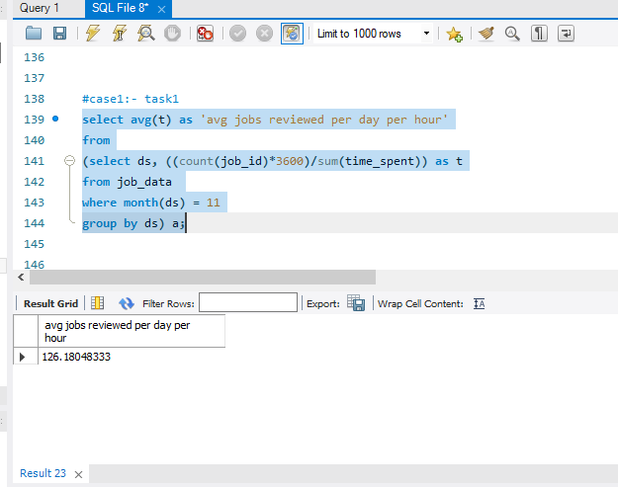

1. **Throughput Analysis:**

* Objective: Calculate the 7-day rolling average of throughput (number of events per second).
* Your Task: Write an SQL query to calculate the 7-day rolling average of throughput. Additionally, explain whether you prefer using the daily metric or the 7-day rolling average for throughput, and why.

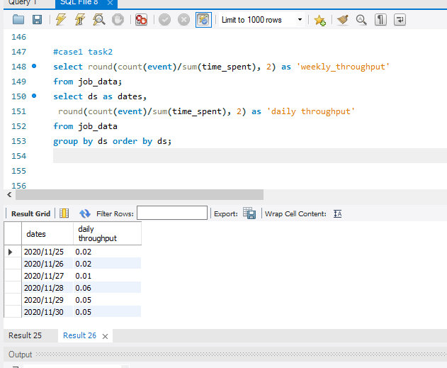

1. **Language Share Analysis:**

* Objective: Calculate the percentage share of each language in the last 30 days.
* Your Task: Write an SQL query to calculate the percentage share of each language over the last 30 days.

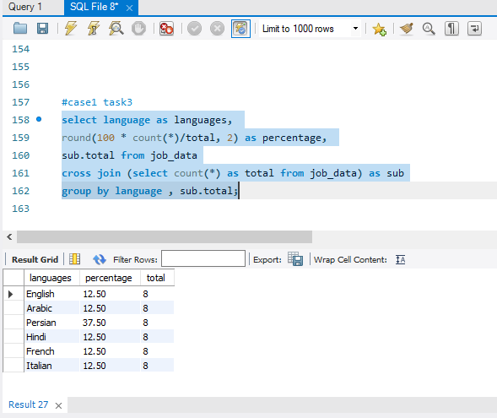

1. **Duplicate Rows Detection:**

* Objective: Identify duplicate rows in the data.
* Your Task: Write an SQL query to display duplicate rows from the job_data table.

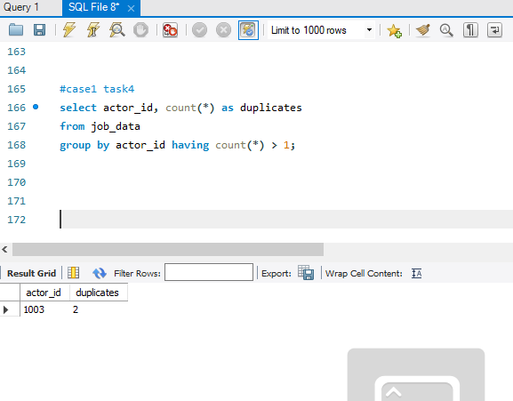

**Case Study 2: Investigating Metric Spike**

Weekly User Engagement:

* Objective: Measure the activeness of users on a weekly basis.
* Your Task: Write an SQL query to calculate the weekly user engagement.

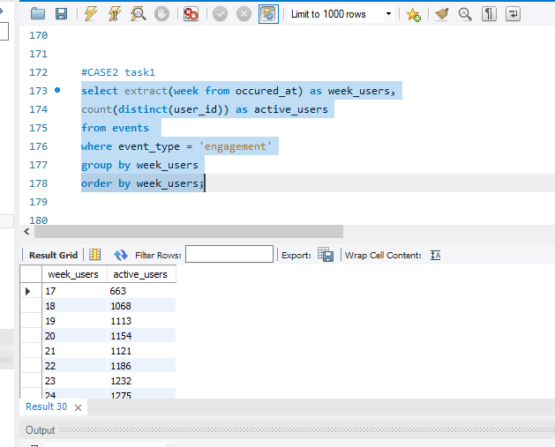

* Highest user week: 28
* Minimum user week: 17

User Growth Analysis:

* Objective: Analyze the growth of users over time for a product.
* Your Task: Write an SQL query to calculate the user growth for the product.

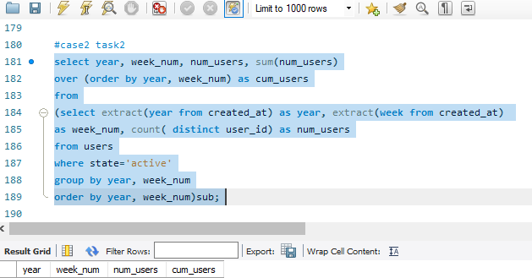

The 12th 33 week of 2014 saw the greatest number of users The lowest was on 35th week of 2014

Weekly Retention Analysis:

* Objective: Analyze the retention of users on a weekly basis after signing up for a product.
* Your Task: Write an SQL query to calculate the weekly retention of users based on their sign-up cohort.

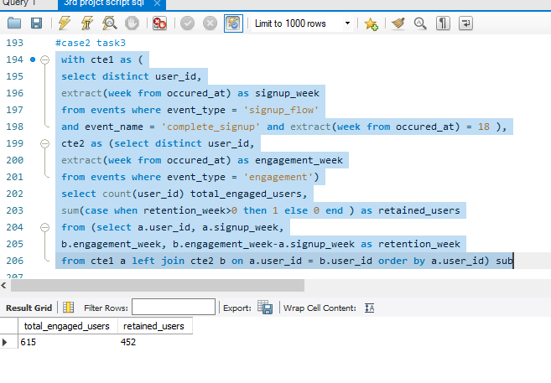

30% of the user retained in week 18 were retained only for the next 7 days.

User 11816 was retained for the longest duration i.e. 17 weeks.

Weekly Engagement Per Device:

* + Objective: Measure the activeness of users on a weekly basis per device.
  + Your Task: Write an SQL query to calculate the weekly engagement per device.

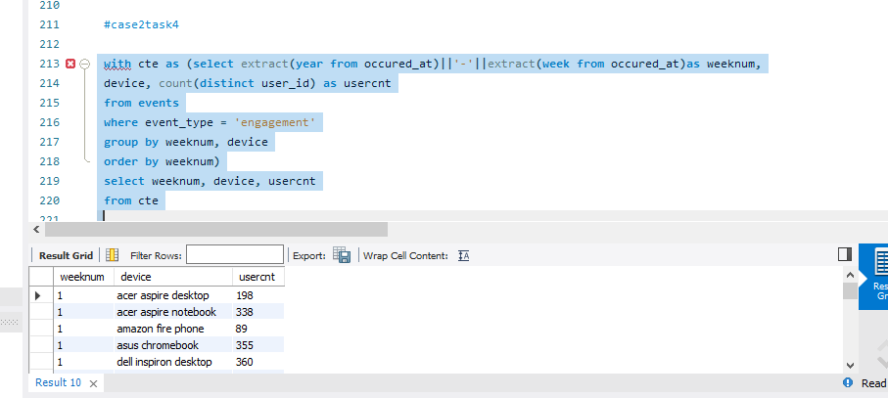

Week 31 & 32 of the year 2014 had the highest user engagement of 317 users each week for the product and the device being used was ‘MacBook Pro’ for both the weeks.

Email Engagement Analysis:

* Objective: Analyze how users are engaging with the email service.
* Your Task: Write an SQL query to calculate the email engagement metrics.

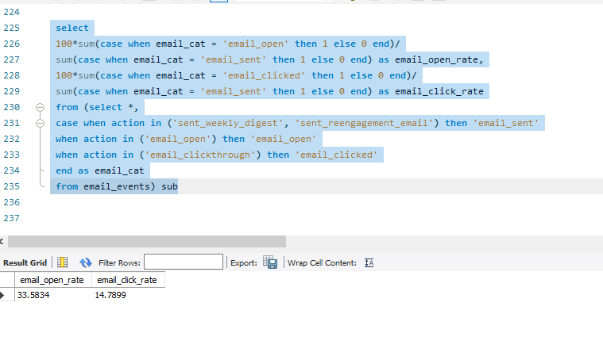

Out of the total email sent, around 35.73% of them were opened and only 15.74% of those emails were clicked.

**RESULTS**

* Less than 0.01 jobs were reviewed each hour of the day throughout the month of November.
* 7 day rolling average is best for throughput.
* The Persian language has the highest share among other languages.
* Out of the total email sent, around 35.73% of them were opened and only 15.74% of those emails were clicked.
* The weekly user engagement is highest in 31st week.
* 33rd & 35th week of 2014 were the highest and lowest of user activity engagement respectively.
* Maximum retained users were only retained for a week, the retention rates were dropped.
* Users who had the highest engagement with the product were operating on ‘MacBook Pro’.
* During the month of august, users recieved the highest number of weekly digest emails.

**THANKYOU**